Judo Ireland

Course Application Form

Course Judo Teachers Foundation Training
For Qualified P.E. Teachers 2013
Payment to: Judo Ireland
Tobergregan, Garristown, Co. Dublin

Name………………………..................................... Qualification………………………………………
School.......................................................................
Address……………………………………………………………………………………………………

Telephone………………Mobile…………………
e-mail……………………………...

Are there any reasons medical or otherwise which may inhibit any of your group taking part in this activity? Yes / No

If Yes, please give details ………………………………………………………………………………………………………………

Please include all fees with Course Application.

I agree to observe the rules & regulations of Judo Ireland and to train with others in a secure & safe environment.

Signed………………………………………………
Date………………….............................................

Location

Judo Course will take place in

St. Josephs CBS
Fairview
Dublin 3

Tuesday 18.00 – 20.00

On the following dates

September 17 & 24

October 01, 08, 15 & 22

November 05, 12, 19 & 26

December 03 & 10
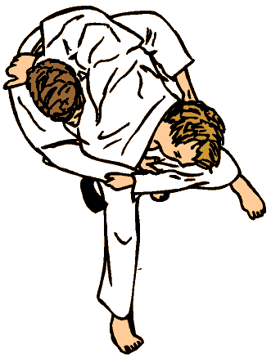



Judo Ireland

www.judoireland.com

in association with

The Embassy of Japan

Will run a

Judo Teachers Training Course
for
Qualified P.E. Teachers
Beginning
Tuesday, 17th September 2013
For 12 weeks
In
St. Joseph’s CBS
Fairview, Dublin 3.

Foundation Judo Course

This course will run Tuesday’s from 6.00 - 8.00 pm, beginning 17th September and ending 10th December.

All participants will need to be qualified to teach Physical Education in the current Irish School structure in order to take part.

Course Content

Course will consist of introduction to:-

- Ukemi (Breakfalls)
- Nagewaza (Throwing techniques)
- Osaekomiwaza (Holding techniques)
- Shimewaza (Strangles & Chokes)
- Kansetsuwaza (Armlocks)
- Kata (Forms)

Reference will be made to Japanese Culture, Philosophy & history to enhance an understanding of Judo.

Assessment

Will be ongoing and take the form of Judo Gradings.

2 Gradings will take place during the course, together with preparation for the next grading which will take place in early 2014.

Certification

Course Certificates will be presented to the successful candidates on the final day of the course, Tuesday 10th December 2013

Course Fee €295.00

Fee Includes:

- New White Judogi (Judo Suit)

- Judo Ireland Individual Membership

- Judo Ireland Grading Fees X 2

- All Course Material & Notes

For further details, contact:

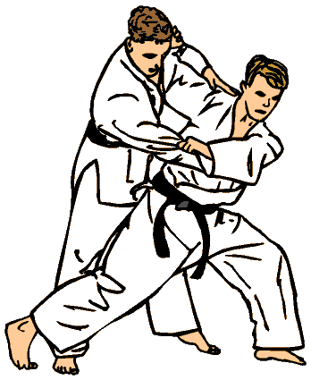
Alan Martin
Technical Director
Judo Ireland

Tel:- 086 - 2703220

e-mail: info@judoireland.com

Limited Number of Places

Course limited to a Maximum of 20 places

Places will be allocated on a first come, first served basis.
Judo
Professor Jigoro Kano, who was born in Japan on October 28, 1860 and who died, May 4, 1938 after a lifetime of promoting it, created judo. In 1882 he founded the Kodokan Judo Institute in Tokyo where he began teaching and which still is the international authority for Judo.
The name Judo was chosen because it means the gentle or yielding way. The popularity of Judo increased dramatically after a famous contest hosted by the Tokyo police in 1886 where the Judo team defeated the most well-known jujutsu school of the time. It then became a part of the Japanese physical education system and began its spread around the world. In 1964 men's Judo competition finally became a part of the Olympics, the first Asian martial art as an official medal sport. In 1992 Judo competition for women was added to the Judo consists primarily of nage-waza (throws), along with katame-waza (grappling), which includes osaekomi-waza (pins), shime-waza (chokes), and kansetsu-waza (joint locks). Additional techniques, including atemi-waza (striking), various joint locks, self defence and weapons are found in the Judo katas. Judo is generally compared to wrestling, but it retains its unique combat forms. Because the founder was involved in education (President of Tokyo University) Judo training emphasizes mental, moral and character development as much as physical training. Most instructors stress the principles of Judo such as the principle of yielding to overcome greater strength or size, as well as the scientific principles of leverage, balance, efficiency, momentum and control. Judo is a good choice for most children to learn because it is safe and fun, and because it emphasizes education and proper development of the body, mind, and character.
Judo training has many forms for different interests. Some students train for competition by sparring and entering the many tournaments that are available. Other students study the traditional art and forms (kata) of Judo. Other students train for self-defence, and yet other students practice Judo for fun and recreation. Black belts are expected to learn all aspects of Judo.

